How to crate triggers

1. Go to pipeline create simple pipeline with set variable activity

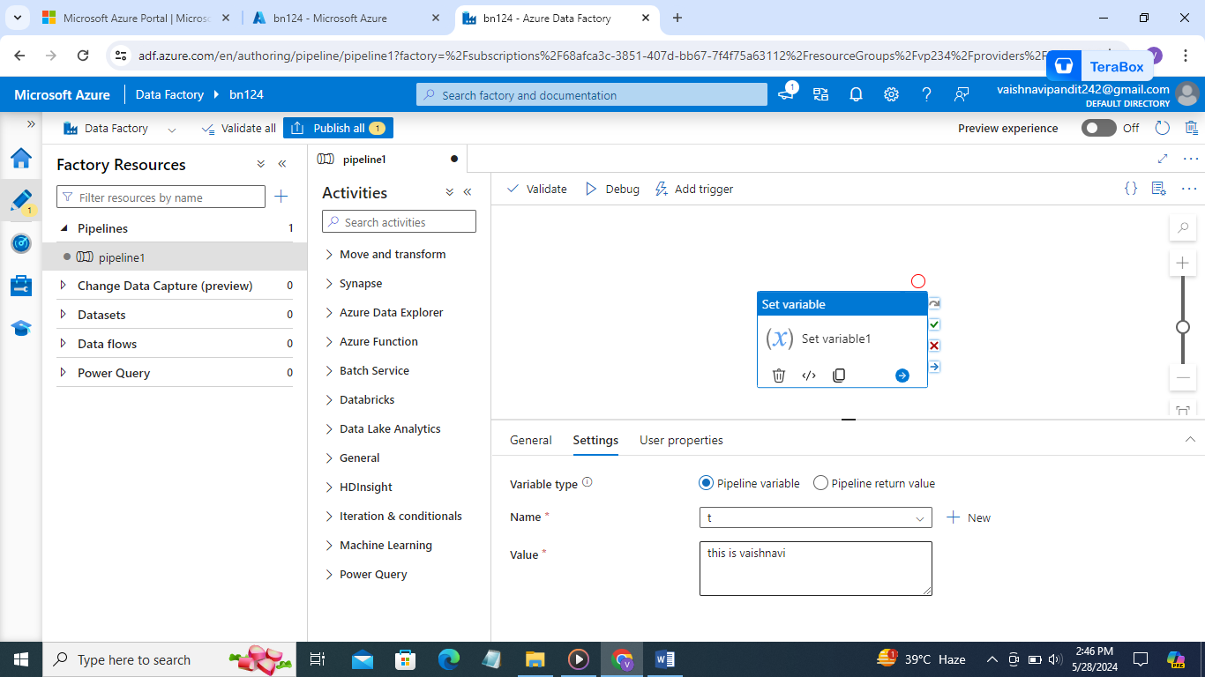

1. Now go to manage->triggers->create new trigger

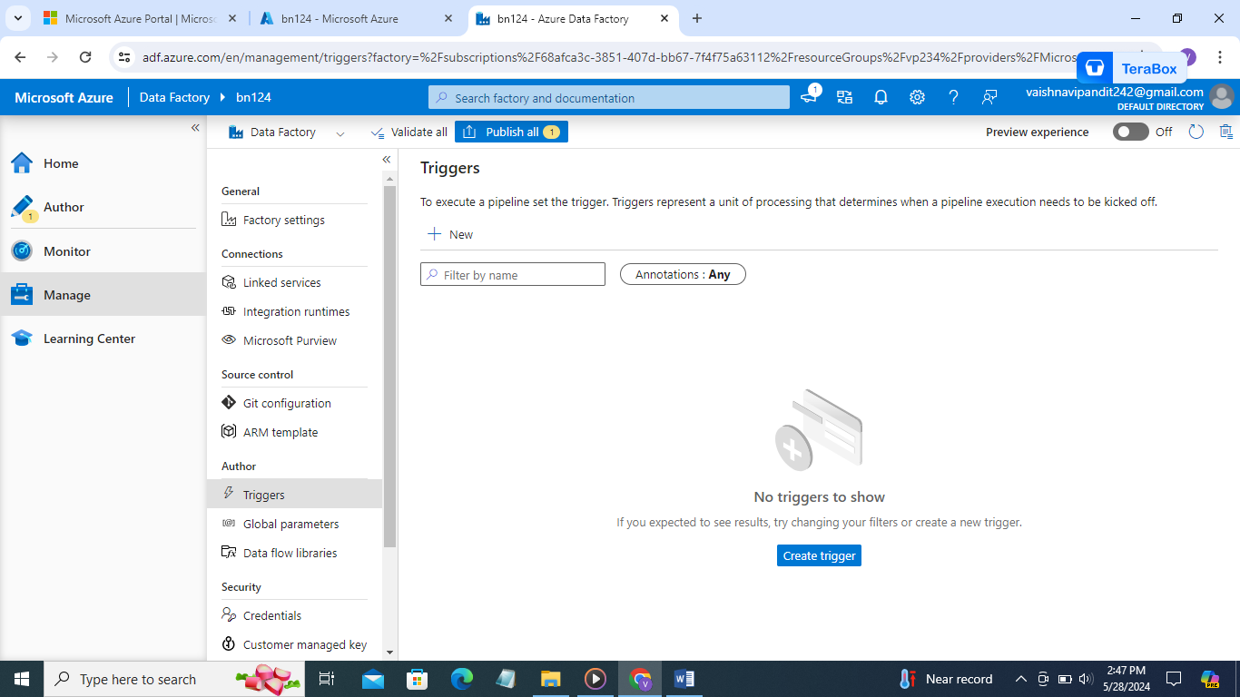

1. Add trigger name type enter recurrence in recurrence we can add time or date or a day if you select a day at which time you want in a day

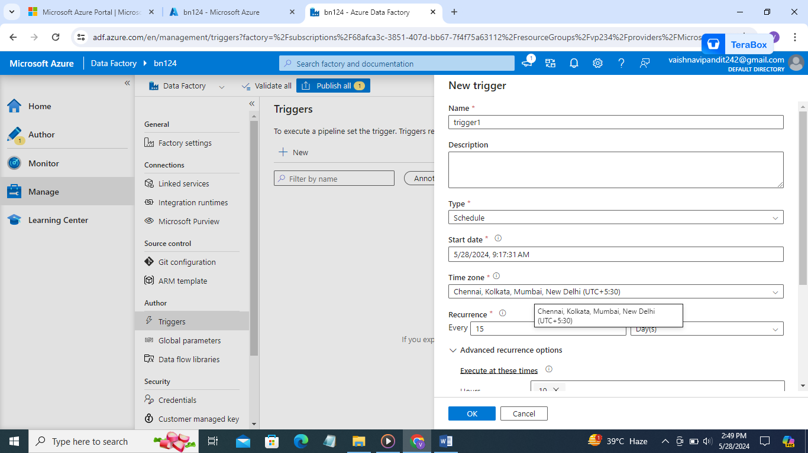

1. You can mention end date also if you want

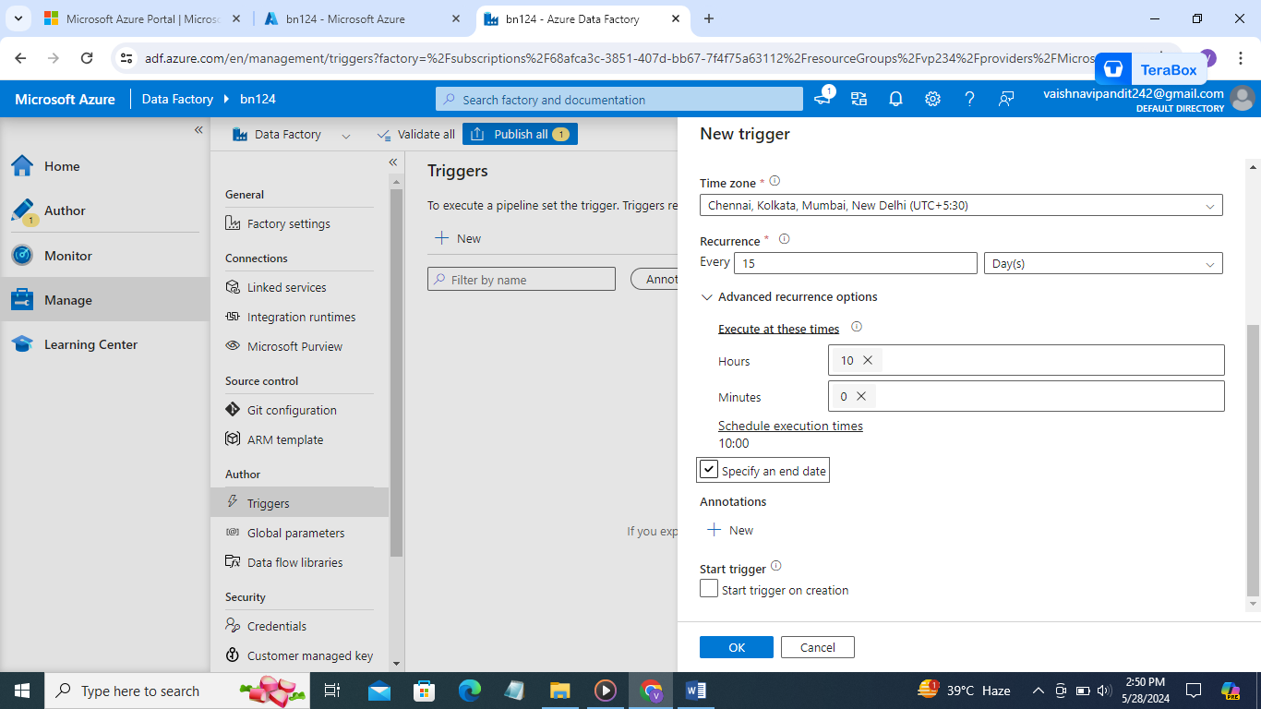

1. Now go to pipeline and in upper side you will find add trigger go there and add the created trigger

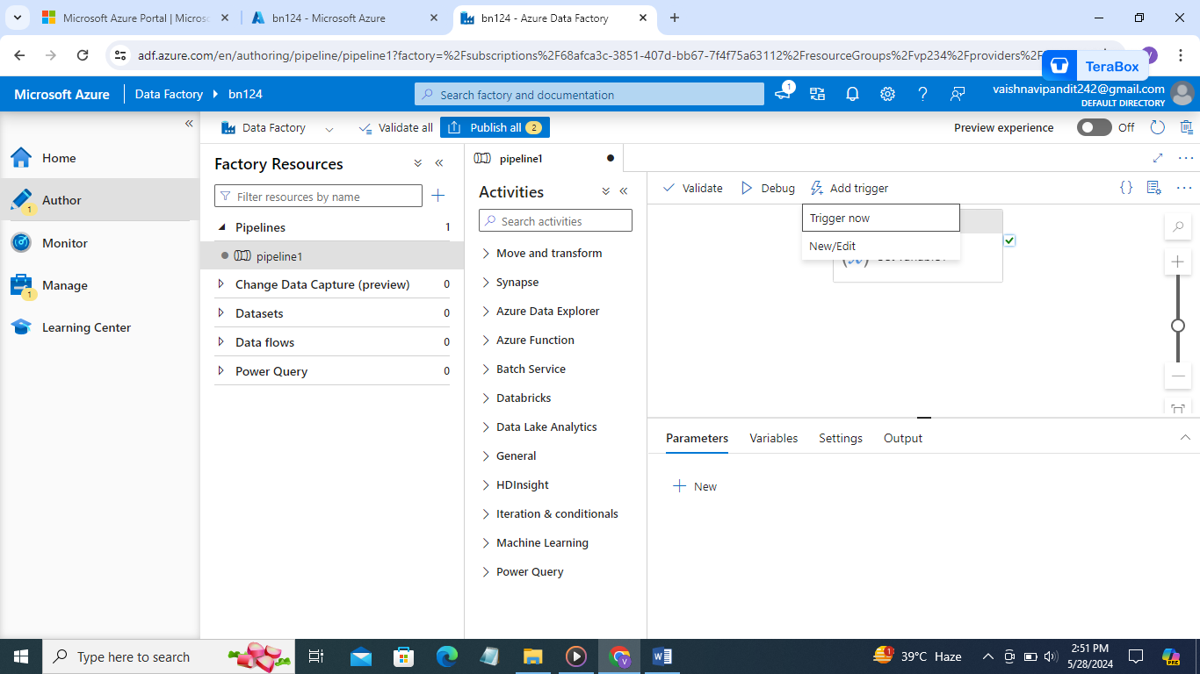

1. Select new

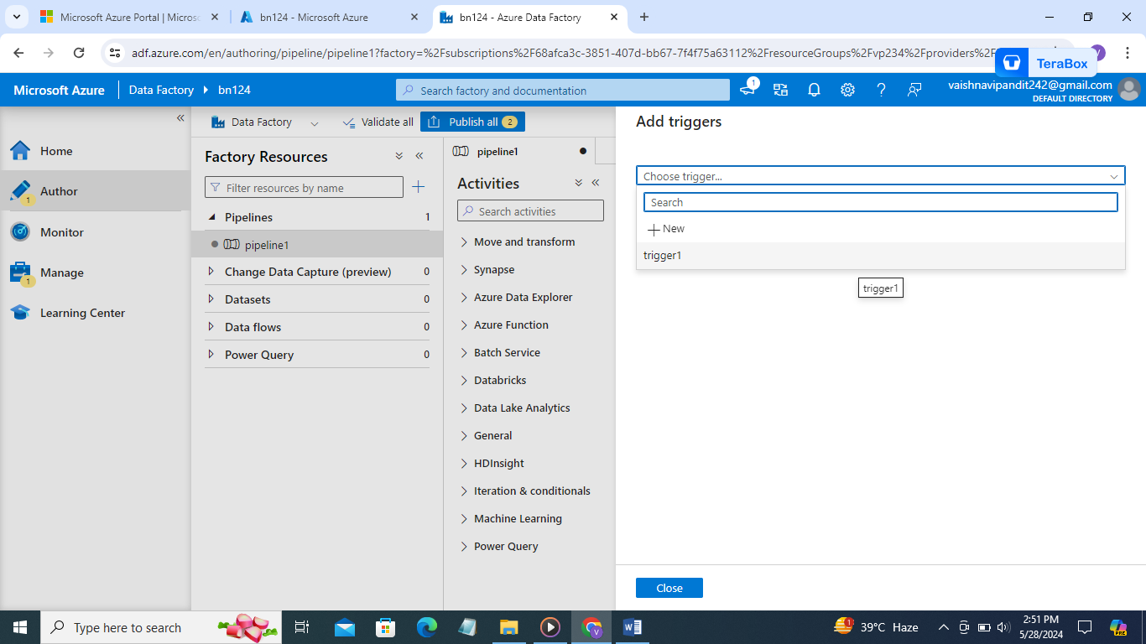

1. Now trigger 1 will be showcased

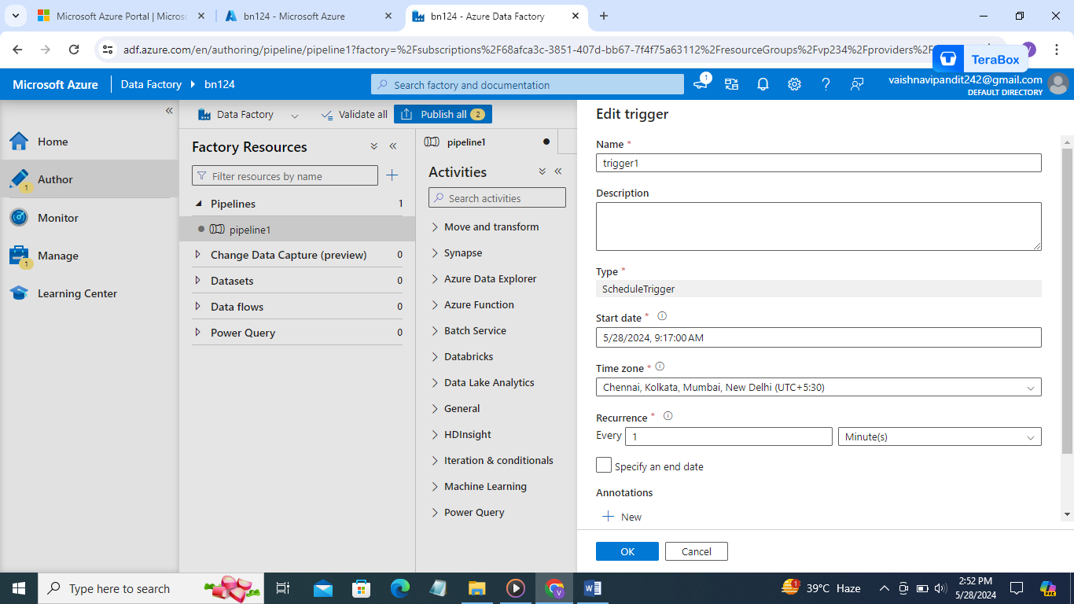

1. Click ok

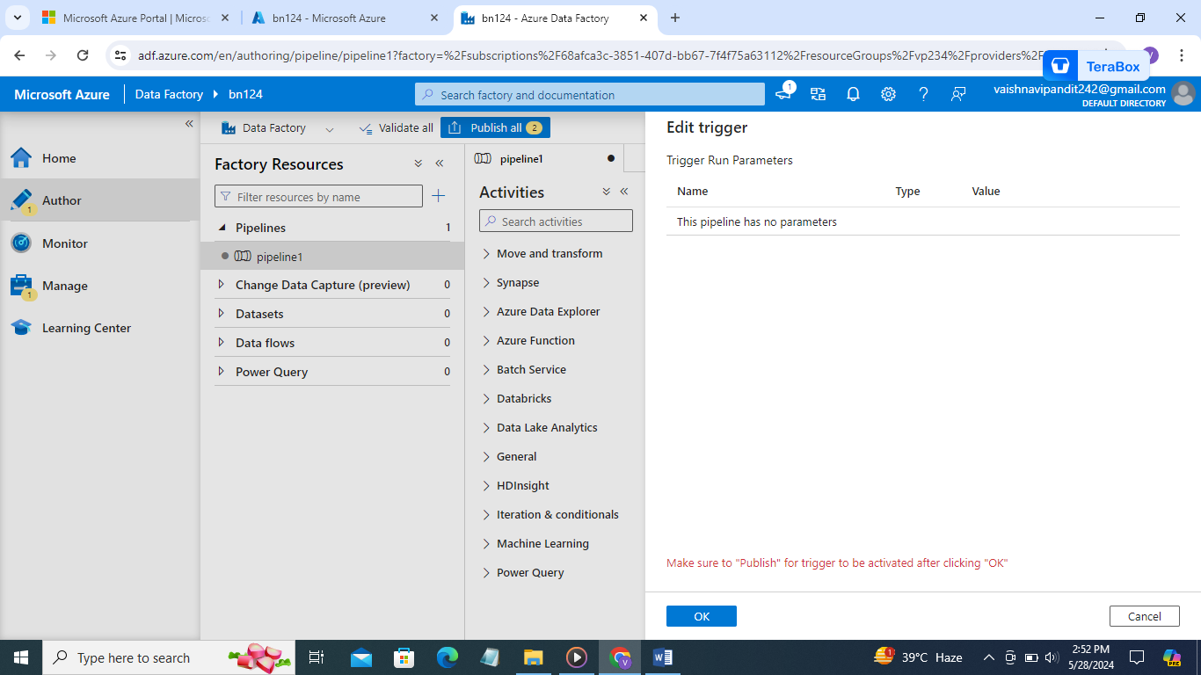

1. Now publish then only trigger will be added

You can see if triggers are running or not go to monitor->pipeline runs->triggered

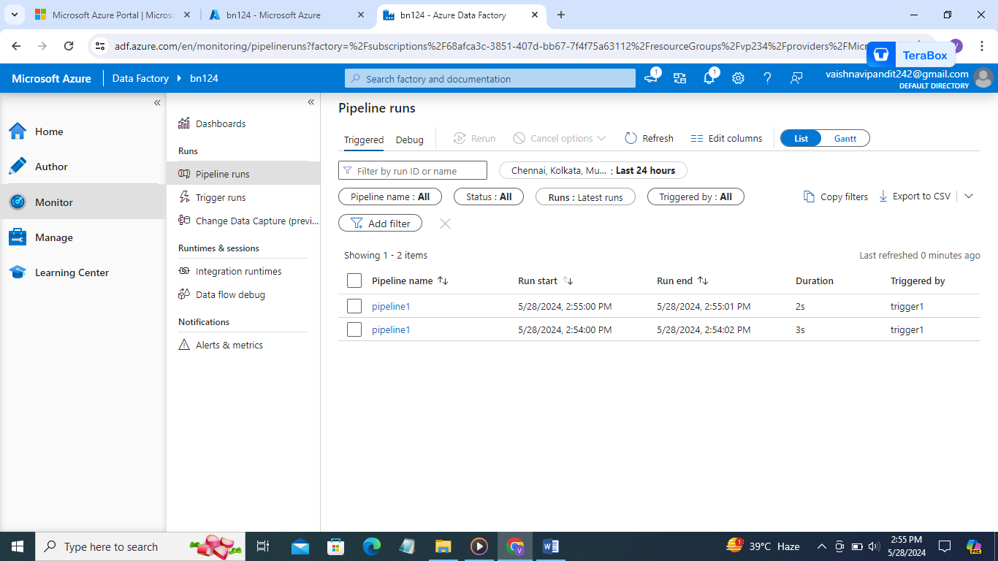

1. Now to stop trigger you can go to triggers in manage and stop or delete trigger

